**DNA Replication**

**Introduction:**

Biologists in the 1940s had difficulty in accepting [DNA](https://www.ncbi.nlm.nih.gov/books/n/mboc4/A4754/def-item/A5084/) as the genetic material because of the apparent simplicity of its chemistry. DNA was known to be a long [polymer](https://www.ncbi.nlm.nih.gov/books/n/mboc4/A4754/def-item/A5655/) composed of only four types of subunits, which resemble one another chemically. Early in the 1950s, DNA was first examined by x-ray diffraction analysis, a technique for determining the three-dimensional atomic structure of a [molecule](https://www.ncbi.nlm.nih.gov/books/n/mboc4/A4754/def-item/A5486/) (discussed in Chapter 8). The early x-ray diffraction results indicated that DNA was composed of two strands of the polymer wound into a helix. The observation that DNA was double-stranded was of crucial significance and provided one of the major clues that led to the Watson-Crick structure of DNA. Only when this model was proposed did DNA's potential for replication and information encoding become apparent. In this [section](https://www.ncbi.nlm.nih.gov/books/n/mboc4/A4754/def-item/A5785/) we examine the structure of the DNA molecule and explain in general terms how it is able to store hereditary information.

**A DNA Molecule Consist of Two Complementary Chains Of Nucleotides:**

A [DNA](https://www.ncbi.nlm.nih.gov/books/n/mboc4/A4754/def-item/A5084/) [molecule](https://www.ncbi.nlm.nih.gov/books/n/mboc4/A4754/def-item/A5486/) consists of two long polynucleotide chains composed of four types of [nucleotide](https://www.ncbi.nlm.nih.gov/books/n/mboc4/A4754/def-item/A5567/) subunits. Each of these chains is known as a DNA chain, or a DNA strand. Hydrogen bonds between the [base](https://www.ncbi.nlm.nih.gov/books/n/mboc4/A4754/def-item/A4875/) portions of the nucleotides hold the two chains together.

**DNA replication:**

The [double helix](https://en.wikipedia.org/wiki/Double_helix) is unwound and each strand acts as a template (blue) for the next strand. [Bases](https://en.wikipedia.org/wiki/Nucleotides) are matched to synthesize the new partner strands (green).

In [molecular biology](https://en.wikipedia.org/wiki/Molecular_biology), DNA replication is the biological process of producing two identical replicas of DNA from one original [DNA](https://en.wikipedia.org/wiki/DNA) molecule. This process occurs in all [living organisms](https://en.wikipedia.org/wiki/Life) and is the basis for [biological inheritance](https://en.wikipedia.org/wiki/Heredity). DNA is made up of a [double helix](https://en.wikipedia.org/wiki/Nucleic_acid_double_helix) of two complementary strands. During replication, these strands are separated. Each strand of the original DNA molecule then serves as a template for the production of its counterpart, a process referred to as [semi conservative replication](https://en.wikipedia.org/wiki/Semiconservative_replication). Cellular [proofreading](https://en.wikipedia.org/wiki/Proofreading_%28Biology%29) and error-checking mechanisms ensure near perfect fidelity for DNA replication.

In a [cell](https://en.wikipedia.org/wiki/Cell_%28biology%29), DNA replication begins at specific locations, or [origins of replication](https://en.wikipedia.org/wiki/Origin_of_replication), in the [genome](https://en.wikipedia.org/wiki/Genome). Unwinding of DNA at the origin and synthesis of new strands results in [replication forks](https://en.wikipedia.org/wiki/Replication_fork) growing bi-directionally from the origin. A number of [proteins](https://en.wikipedia.org/wiki/Protein) are associated with the replication fork to help in the initiation and continuation of DNA synthesis. Most prominently, [DNA polymerase](https://en.wikipedia.org/wiki/DNA_polymerase) synthesizes the new strands by adding [nucleotides](https://en.wikipedia.org/wiki/Nucleotides) that complement each (template) strand. DNA replication occurs during the S-stage of [interphase](https://en.wikipedia.org/wiki/Interphase).

DNA replication can also be performed [in vitro](https://en.wikipedia.org/wiki/In_vitro) (artificially, outside a cell). DNA polymerases isolated from cells and artificial DNA primers can be used to initiate DNA synthesis at known sequences in a template DNA molecule. The [polymerase chain reaction](https://en.wikipedia.org/wiki/Polymerase_chain_reaction) (PCR), a common laboratory technique, cyclically applies such artificial synthesis to amplify a specific target DNA fragment from a pool of DNA.

[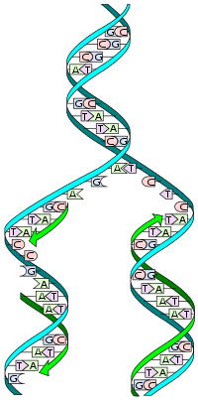](https://en.wikipedia.org/wiki/File:DNA_replication_split.svg)

**DNA structures:**

DNA usually exists as a double-stranded structure, with both strands coiled together to form the characteristic [double-helix](https://en.wikipedia.org/wiki/Double-helix). Each single strand of DNA is a chain of four types of [nucleotides](https://en.wikipedia.org/wiki/Nucleotide). Nucleotides in DNA contain a [deoxyribose](https://en.wikipedia.org/wiki/Deoxyribose) sugar, a [phosphate](https://en.wikipedia.org/wiki/Phosphate), and a [nucleobase](https://en.wikipedia.org/wiki/Nucleobase). The four types of [nucleotide](https://en.wikipedia.org/wiki/Nucleotide) correspond to the four [nucleobase](https://en.wikipedia.org/wiki/Nucleobase) [adenine](https://en.wikipedia.org/wiki/Adenine), [cytosine](https://en.wikipedia.org/wiki/Cytosine), [guanine](https://en.wikipedia.org/wiki/Guanine), and [thymine](https://en.wikipedia.org/wiki/Thymine), commonly abbreviated as A,C, G and T. Adenine and guanine are [purine](https://en.wikipedia.org/wiki/Purine) bases, while cytosine and thymine are [pyrimidine](https://en.wikipedia.org/wiki/Pyrimidine). These nucleotides form [phosphodiester bonds](https://en.wikipedia.org/wiki/Phosphodiester_bonds), creating the phosphate-de-oxyribose backbone of the DNA double helix with the nuclei bases pointing inward (i.e., toward the opposing strand). Nucleotides (bases) are matched between strands through [hydrogen bonds](https://en.wikipedia.org/wiki/Hydrogen_bonding) to form [base pairs](https://en.wikipedia.org/wiki/Base_pair). Adenine pairs with thymine (two hydrogen bonds), and guanine pairs with cytosine (stronger: three hydrogen bonds).

[DNA strands have a directionality](https://en.wikipedia.org/wiki/Directionality_%28molecular_biology%29), and the different ends of a single strand are called the "3' (three-prime) end" and the "5' (five-prime) end". By convention, if the base sequence of a single strand of DNA is given, the left end of the sequence is the 5' end, while the right end of the sequence is the 3' end. The strands of the double helix are anti-parallel with one being 5' to 3', and the opposite strand 3' to 5'. These terms refer to the carbon atom in deoxyribose to which the next phosphate in the chain attaches. Directionality has consequences in DNA synthesis, because DNA polymerase can synthesize DNA in only one direction by adding nucleotides to the 3' end of a DNA strand.

The pairing of complementary bases in DNA (through [hydrogen bonding](https://en.wikipedia.org/wiki/Hydrogen_bonding)) means that the information contained within each strand is redundant. Phosphodiester (intra-strand) bonds are stronger than hydrogen (inter-strand) bonds. This allows the strands to be separated from one another. The nucleotides on a single strand can therefore be used to reconstruct nucleotides on a newly synthesized partner strand.

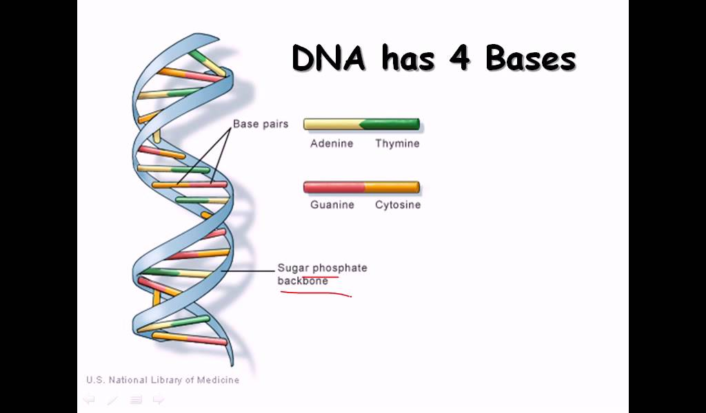

## DNA polymerase:

DNA polymerase adds nucleotides to the 3' end of a strand of DNA. If a mismatch is accidentally incorporated, the polymerase is inhibited from further extension. Proofreading removes the mismatched nucleotide and extension continues.

[DNA polymerases](https://en.wikipedia.org/wiki/DNA_polymerase) are a family of [enzymes](https://en.wikipedia.org/wiki/Enzyme) that carry out all forms of DNA replication.DNA polymerases in general cannot initiate synthesis of new strands, but can only extend an existing DNA or RNA strand paired with a template strand. To begin synthesis, a short fragment of RNA, called a [primer](https://en.wikipedia.org/wiki/Primer_%28molecular_biology%29), must be created and paired with the template DNA strand.

DNA polymerase adds a new strand of DNA by extending the 3' end of an existing nucleotide chain, adding new [nucleotides](https://en.wikipedia.org/wiki/Nucleotide) matched to the template strand one at a time via the creation of [phosphodiester bonds](https://en.wikipedia.org/wiki/Phosphodiester_bond). The energy for this process of DNA polymerization comes from hydrolysis of the [high-energy phosphate](https://en.wikipedia.org/wiki/High-energy_phosphate) (phosphoanhydride) bonds between the three phosphates attached to each unincorporated [base](https://en.wikipedia.org/wiki/Nucleotide). (Free bases with their attached phosphate groups are called [nucleotides](https://en.wikipedia.org/wiki/Nucleotide); in particular, bases with three attached phosphate groups are called [nucleoside triphosphates](https://en.wikipedia.org/wiki/Nucleoside_triphosphate).) When a nucleotide is being added to a growing DNA strand, the formation of a phosphodiester bond between the proximal phosphates of the nucleotide to the growing chain is accompanied by hydrolysis of a high-energy phosphate bond with release of the two distal phosphates as a [pyrophosphate](https://en.wikipedia.org/wiki/Pyrophosphate). Enzymatic hydrolysis of the resulting pyrophosphate into inorganic phosphate consumes a second high-energy phosphate bond and renders the reaction effectively irreversible.

In general, DNA polymerases are highly accurate, with an intrinsic error rate of less than one mistake for every 107 nucleotides added .In addition, some DNA polymerases also have proofreading ability; they can remove nucleotides from the end of a growing strand in order to correct mismatched bases. Finally, post-replication mismatch repair mechanisms monitor the DNA for errors, being capable of distinguishing mismatches in the newly synthesized DNA strand from the original strand sequence. Together, these three discrimination steps enable replication fidelity of less than one mistake for every 109 nucleotides added.

The rate of DNA replication in a living cell was first measured as the rate of phage T4 DNA elongation in phage-infected E. coli. During the period of exponential DNA increase at 37 °C, the rate was 749 nucleotides per second. The mutation rate per base pair per replication during phage T4 DNA synthesis is 1.7 per 108.

[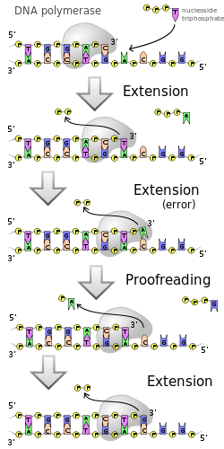](https://en.wikipedia.org/wiki/File:DNA_polymerase.svg)

# Transcription / DNA Transcription:

Transcription is the process by which the information in a strand of DNA is copied into a new molecule of messenger RNA (mRNA). DNA safely and stably stores genetic material in the nuclei of cells as a reference, or template. Meanwhile, mRNA is comparable to a copy from a reference book because it carries the same information as DNA but is not used for long-term storage and can freely exit the nucleus. Although the mRNA contains the same information, it is not an identical copy of the DNA segment, because its sequence is complementary to the DNA template.

Transcription is carried out by an enzyme called RNA polymerase and a number of accessory proteins called transcription factors. Transcription factors can bind to specific DNA sequences called enhancer and promoter sequences in order to recruit RNA polymerase to an appropriate transcription site. Together, the transcription factors and RNA polymerase form a complex called the transcription initiation complex. This complex initiates transcription, and the RNA polymerase begins mRNA synthesis by matching complementary bases to the original DNA strand. The mRNA molecule is elongated and, once the strand is completely synthesized, transcription is terminated. The newly formed mRNA copies of the gene then serve as blueprints for protein synthesis during the process of translation.

## Replication process:

DNA replication, like all biological polymerization processes, proceeds in three enzymatically catalyzed and coordinated steps:

* initiation,
* elongation
* Termination.

### Initiation:

For a [cell to divide](https://en.wikipedia.org/wiki/Cell_division), it must first replicate its DNA. This process is initiated at particular points in the DNA, known as "[origins](https://en.wikipedia.org/wiki/Origin_of_replication)", which are targeted by [initiator proteins](https://en.wikipedia.org/w/index.php?title=Initiator_protein&action=edit&redlink=1). In [E. coli](https://en.wikipedia.org/wiki/Escherichia_coli) this protein is [DNA](https://en.wikipedia.org/wiki/DnaA); in [yeast](https://en.wikipedia.org/wiki/Yeast), this is the [origin recognition complex](https://en.wikipedia.org/wiki/Origin_recognition_complex). Sequences used by initiator proteins tend to be "AT-rich" (rich in adenine and thymine bases), because A-T base pairs have two hydrogen bonds (rather than the three formed in a C-G pair) and thus are easier to decouple. Once the origin has been located, these initiators recruit other proteins and form the [pre-replication complex](https://en.wikipedia.org/wiki/Pre-replication_complex), which unzips the double-stranded DNA.

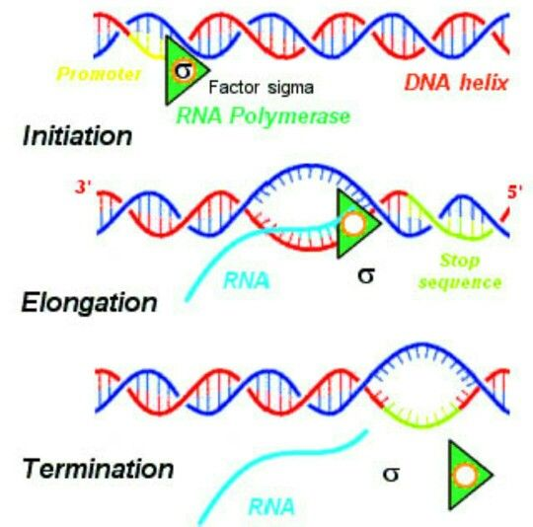

### Elongation:

DNA polymerase has 5'-3' activity. All known DNA replication systems require a free 3' [hydroxyl](https://en.wikipedia.org/wiki/Hydroxyl) group before synthesis can be initiated (the DNA template is read in 3' to 5' direction whereas a new strand is synthesized in the 5' to 3' direction—this is often confused). Four distinct mechanisms for initiation of synthesis are recognized:

1. All cellular life forms and many DNA [viruses](https://en.wikipedia.org/wiki/Virus), [phages](https://en.wikipedia.org/wiki/Phage) and [plasmids](https://en.wikipedia.org/wiki/Plasmid) use a [primate](https://en.wikipedia.org/wiki/Primase) to synthesize a short RNA primer with a free 3' OH group which is subsequently elongated by a DNA polymerase.
2. The retro elements (including [retroviruses](https://en.wikipedia.org/wiki/Retrovirus)) employ a transfer RNA that primes DNA replication by providing a free 3′ OH that is used for elongation by the [reverse transcriptase](https://en.wikipedia.org/wiki/Reverse_transcriptase).
3. In the [adenoviruses](https://en.wikipedia.org/wiki/Adenovirus) and the [φ29 family](https://en.wikipedia.org/w/index.php?title=%CE%A629_family&action=edit&redlink=1) of [bacteriophages](https://en.wikipedia.org/wiki/Bacteriophage), the 3' OH group is provided by the side chain of an amino acid of the genome attached protein (the terminal protein) to which nucleotides are added by the DNA polymerase to form a new strand.
4. In the single stranded DNA viruses — a group that includes the [circoviruses](https://en.wikipedia.org/wiki/Circovirus), the [Gemini viruses](https://en.wikipedia.org/wiki/Geminivirus), the [parvoviruses](https://en.wikipedia.org/wiki/Parvovirus) and others — and also the many phages and [plasmids](https://en.wikipedia.org/wiki/Plasmid) that use the rolling circle replication (RCR) mechanism, the RCR endonuclease creates a nick in the genome strand (single stranded viruses) or one of the DNA strands (plasmids). The 5′ end of the nicked strand is transferred to a [tyrosine](https://en.wikipedia.org/wiki/Tyrosine) residue on the nuclease and the free 3′ OH group is then used by the DNA polymerase to synthesize the new strand.

The first is the best known of these mechanisms and is used by the cellular organisms. In this mechanism, once the two strands are separated, [primase](https://en.wikipedia.org/wiki/Primase) adds RNA primers to the template strands. The leading strand receives one RNA primer while the lagging strand receives several. The leading strand is continuously extended from the primer by a DNA polymerase with high [processivity](https://en.wikipedia.org/wiki/Processivity), while the lagging strand is extended discontinuously from each primer forming [Okazaki fragments](https://en.wikipedia.org/wiki/Okazaki_fragments). [RNA ligase](https://en.wikipedia.org/wiki/RNase) removes the primer RNA fragments, and a low processivity DNA polymerase distinct from the replicative polymerase enters to fill the gaps. When this is complete, a single nick on the leading strand and several nicks on the lagging strand can be found. [Ligase](https://en.wikipedia.org/wiki/Ligase) works to fill these nicks in, thus completing the newly replicated DNA molecule.

The primase used in this process differs significantly between [bacteria](https://en.wikipedia.org/wiki/Bacteria) and [archaea](https://en.wikipedia.org/wiki/Archaea)/[eukaryotes](https://en.wikipedia.org/wiki/Eukaryote). Bacteria use a primase belonging to the [Dna G](https://en.wikipedia.org/wiki/DnaG) protein superfamily which contains a catalytic domain of the TOPRIM fold type. The TOPRIM fold contains a α/β core with four conserved strands in a [Grossmann-like](https://en.wikipedia.org/wiki/Rossmann_fold) topology. This structure is also found in the catalytic domains of [topoisomerase](https://en.wikipedia.org/wiki/Topoisomerase), topoisomerase II, the OLD-family nucleases and DNA repair proteins related to the RecR protein.

The primase used by archaea and eukaryotes, in contrast, contains a highly derived version of the [RNA recognition motif](https://en.wikipedia.org/wiki/RNA_recognition_motif) (RRM). This primase is structurally similar to many viral RNA-dependent RNA polymerases, reverse transcriptases, cyclic nucleotide generating cyclases and DNA polymerases of the A/B/Y families that are involved in DNA replication and repair. In eukaryotic replication, the primase forms a complex with Pol α.

Multiple DNA polymerases take on different roles in the DNA replication process. In [E. coli](https://en.wikipedia.org/wiki/Escherichia_coli), [DNA Pol III](https://en.wikipedia.org/wiki/Pol_III) is the polymerase enzyme primarily responsible for DNA replication. It assembles into a replication complex at the replication fork that exhibits extremely high processivity, remaining intact for the entire replication cycle. In contrast, [DNA Pol I](https://en.wikipedia.org/wiki/Pol_I) is the enzyme responsible for replacing RNA primers with DNA. DNA Pol I has a 5' to 3' [exonuclease](https://en.wikipedia.org/wiki/Exonuclease) activity in addition to its polymerase activity, and uses its exonuclease activity to degrade the RNA primers ahead of it as it extends the DNA strand behind it, in a process called [nick translation](https://en.wikipedia.org/wiki/Nick_translation). Pol I is much less processive than Pol III because its primary function in DNA replication is to create many short DNA regions rather than a few very long regions.

In [eukaryotes](https://en.wikipedia.org/wiki/Eukaryote), the low-processivity enzyme, Pol α, helps to initiate replication. The high-processivity extension enzymes are Pol δ and Pol ε.

As DNA synthesis continues, the original DNA strands continue to unwind on each side of the bubble, forming a [replication fork](https://en.wikipedia.org/wiki/Replication_fork) with two prongs. In bacteria, which have a single origin of replication on their circular chromosome, this process creates a "[theta structure](https://en.wikipedia.org/wiki/Theta_structure)" (resembling the Greek letter theta: θ). In contrast, eukaryotes have longer linear chromosomes and initiate replication at multiple origins within these.



### Termination:

DNA replication, like all mechanisms, must have a way to terminate itself. This avoids situations where too much DNA is present in a cell (known as aneuploidy) or alternatively where cells are replicated too frequently (leading to tumour formation). This article will focus on termination of replication in both prokaryotes and eukaryotes, such as E.coli and humans respectively



# Translation / DNA Translation:

Translation is the process of translating the sequence of a messenger RNA (mRNA) molecule to a sequence of amino acids during protein synthesis. The genetic code describes the relationship between the sequence of base pairs in a gene and the corresponding amino acid sequence that it encodes. In the cell cytoplasm, the ribosome reads the sequence of the mRNA in groups of three bases to assemble the protein. Here is a more complete definition of translation

The mRNA formed in transcription is transported out of the nucleus, into the cytoplasm, to the ribosome (the cell's protein synthesis factory). Here, it directs protein synthesis. Messenger RNA is not directly involved in protein synthesis − transfer RNA (tRNA) is required for this. The process by which mRNA directs protein synthesis with the assistance of tRNA is called *translation*.

The ribosome is a very large complex of RNA and protein molecules. Each three-base stretch of mRNA (triplet) is known as a *codon*, and one codon contains the information for a specific amino acid. As the mRNA passes through the ribosome, each codon interacts with the *anticodon* of a specific transfer RNA (tRNA) molecule by Watson-Crick base pairing. This tRNA molecule carries an amino acid at its 3′-terminus, which is incorporated into the growing protein chain. The tRNA is then expelled from the ribosome the steps involved in protein synthesis.

[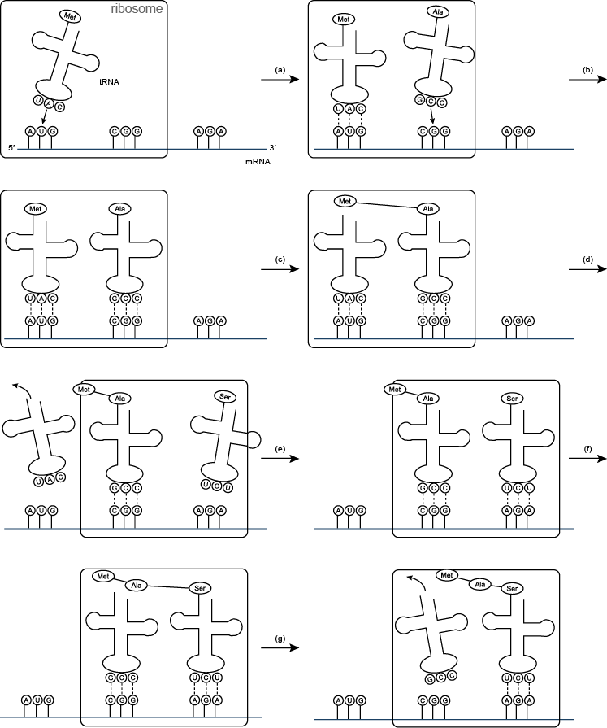](http://www.atdbio.com/img/articles/translation-large.png)

Translation(a) and (b) tRNA molecules bind to the two binding sites of the ribosome, and by hydrogen bonding to the mRNA; (c) a peptide bond forms between the two amino acids to make a dipeptide, while the tRNA molecule is left uncharged; (d) the uncharged tRNA molecule leaves the ribosome, while the ribosome moves one codon to the right (the dipeptide is translocated from one binding site to the other); (e) another tRNA molecule binds; (f) a peptide bond forms between the two amino acids to make a tripeptide; (g) the uncharged tRNA molecule leaves the ribosome.

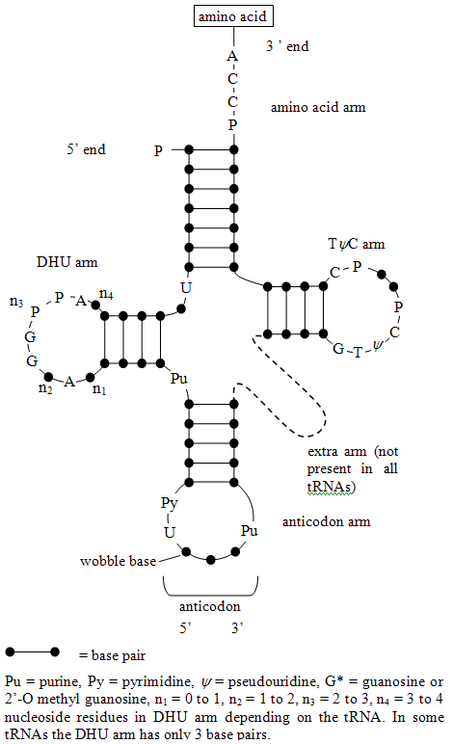

Each amino acid has its own special tRNA (or set of tRNA). For example, the tRNA for phenylalanine (tRNAPhe) is different from that for histidine (tRNA). Each amino acid is attached to its tRNA through the 3′-OH group to form an ester which reacts with the α-amino group of the terminal amino-acid of the growing protein chain to form a new amide bond (peptide bond) during protein synthesis. The reaction of esters with amines is generally favourable but the rate of reaction is increased greatly in the ribosome.

[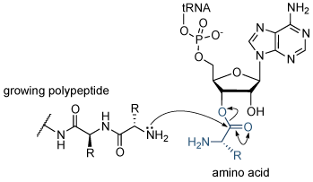](http://www.atdbio.com/img/articles/protein-synthesis-tRNA-large.png)

Protein synthesis Reaction of the growing polypeptide chain with the 3′-end of the charged tRNA. The amino acid is transferred from the tRNA molecule to the protein.

Each transfer RNA molecule has a well defined tertiary structure that is recognized by the enzyme aminoacyl tRNA synthetase, which adds the correct amino acid to the 3′-end of the uncharged tRNA. The presence of modified nucleosides is important in stabilizing the tRNA structure. Some of these modifications.

[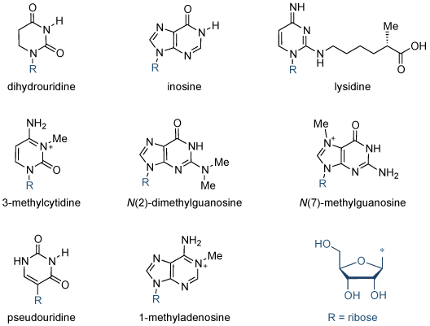](http://www.atdbio.com/img/articles/tRNA-modified-bases-large.png)

# Translation:

The genetic information stored in DNA is a living archive of instructions that cells use to accomplish the functions of life. Inside each cell, catalysts seek out the appropriate information from this archive and use it to build new proteins — proteins that make up the structures of the cell, run the biochemical reactions in the cell, and are sometimes manufactured for export. Although all of the cells that make up a multicellular organism contain identical genetic information, functionally different cells within the organism use different sets of catalysts to express only specific portions of these instructions to accomplish the functions of life.

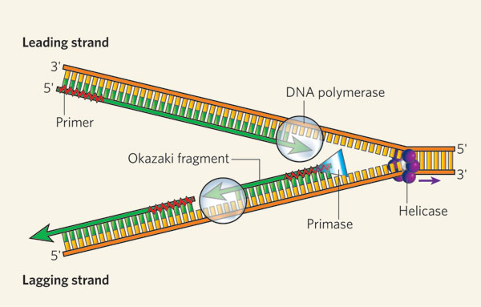

The helicase unzips the double-stranded DNA for replication, making a forked structure. The primase generates short strands of RNA that bind to the single-stranded DNA to initiate DNA synthesis by the DNA polymerase. This enzyme can work only in the 5' to 3' direction, so it replicates the leading strand continuously. Lagging-strand replication is discontinuous, with short Okazaki fragments being formed and later linked together.

One factor that helps ensure precise [replication](http://www.nature.com/scitable/topicpage/cells-can-replicate-their-dna-precisely-6524830) is the [double-helical structure of DNA](http://www.nature.com/scitable/topicpage/dna-is-a-structure-that-encodes-biological-6493050) itself. In particular, the two strands of the DNA double helix are made up of combinations of molecules called **nucleotides**. DNA is constructed from just four different **nucleotides** — **adenine** (A), **thymine** (T), **cytosine** (C), and **guanine** (G) — each of which is named for the nitrogenous base it contains. Moreover, the nucleotides that form one strand of the DNA double helix always bond with the nucleotides in the other strand according to a pattern known as **complementary** **base**-**pairing** — specifically, A always pairs with T, and C always pairs with G. Thus, during cell division, the paired strands unravel and each strand serves as the template for synthesis of a new complementary strand.

## How Does the Whole Process Result in New Proteins?

After the transcription of DNA to mRNA is complete, translation — or the reading of these mRNAs to make proteins — begins. Recall that mRNA molecules are single stranded, and the order of their bases — A, U, C, and G — is complementary to that in specific portions of the cell's DNA. Each mRNA dictates the order in which amino acids should be added to a growing protein as it is synthesized. In fact, every amino acid is represented by a three-nucleotide sequence or codon along the mRNA molecule. For example, AGC is the mRNA codon for the amino acid serine, and UAA is a signal to stop translating a protein — also called the stop codon.

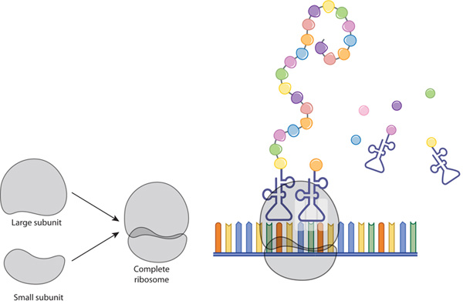

A ribosome is composed of two subunits: large and small. During translation, ribosomal subunits assemble together like a sandwich on the strand of mRNA, where they proceed to attract tRNA molecules tethered to amino acids (circles). A long chain of amino acids emerges as the ribosome decodes the mRNA sequence into a polypeptide, or a new protein.

Molecules of tRNA are responsible for matching amino acids with the appropriate codons in mRNA. Each tRNA molecule has two distinct ends, one of which binds to a specific amino acid, and the other which binds to the corresponding mRNA codon. During [translation](http://www.nature.com/scitable/topicpage/the-information-in-dna-determines-cellular-function-6523228), these tRNAs carry amino acids to the ribosome and join with their complementary codons. Then, the assembled amino acids are joined together as the ribosome, with its resident rRNAs, moves along the mRNA molecule in a ratchet-like motion. The resulting protein chains can be hundreds of amino acids in length, and synthesizing these molecules requires a huge amount of chemical energy.

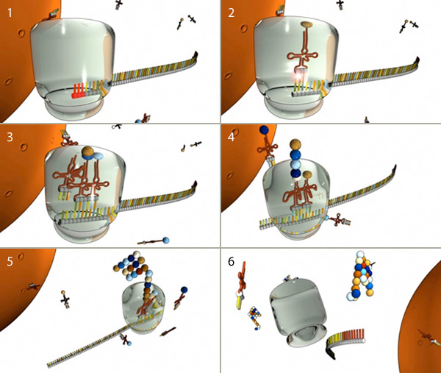

(1) Translation begins when a ribosome (gray) docks on a start codon (red) of an mRNA molecule in the cytoplasm.(2) tRNA molecules attached to amino acids (spheres) dock at the corresponding triplet codon sequence on the mRNA molecule. (3, 4, and 5) This process repeats over and over, with multiple tRNAs docking and connecting successive amino acids into a growing chain that elongates out of the top of the ribosome. (6) When the ribosome encounters a stop codon, it falls off the mRNA molecule and releases the protein for use in the cell.